Marden Medical Practice

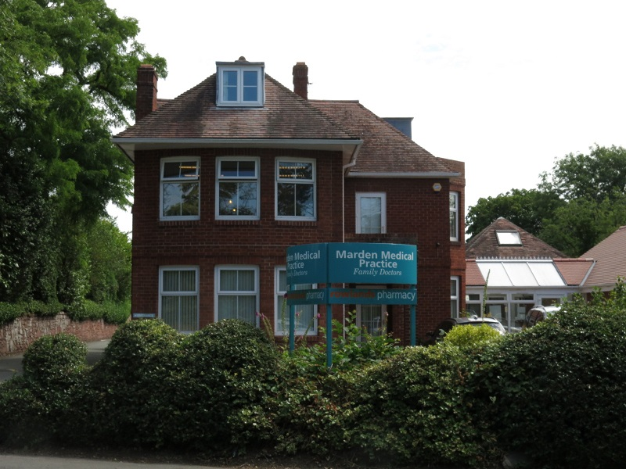
Marden Medical Practice
25 Sutton Road
Shrewsbury
Shropshire
SY2 6DL

Tel: 01743 241313
Email: marden.marden@nhs.net
Web: www.mardenpractice.gpsurgery.net

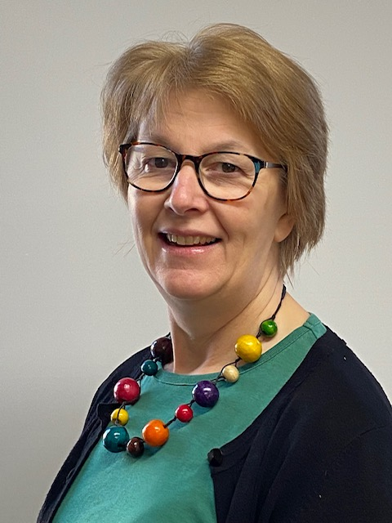ery.net 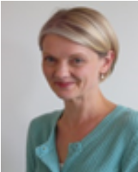

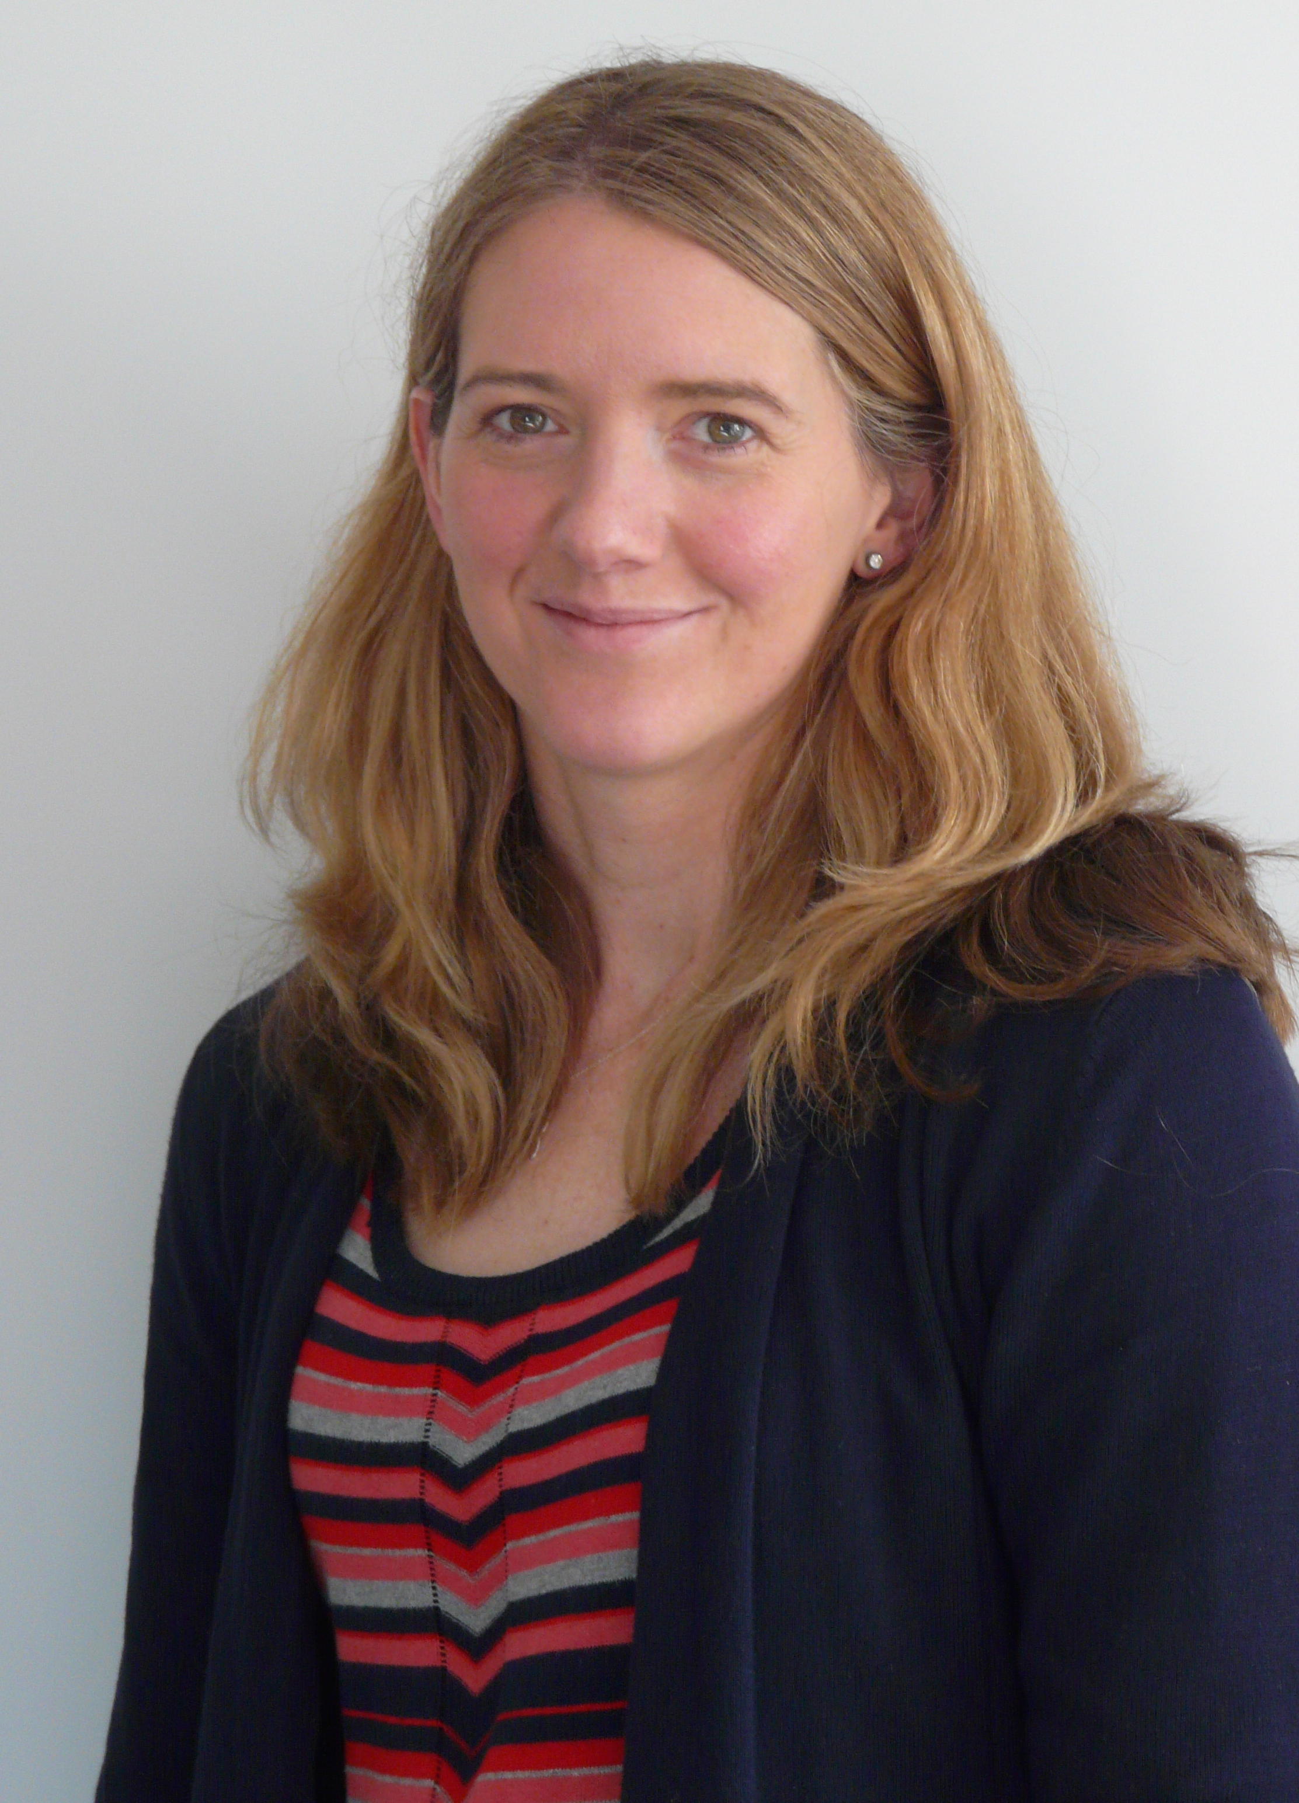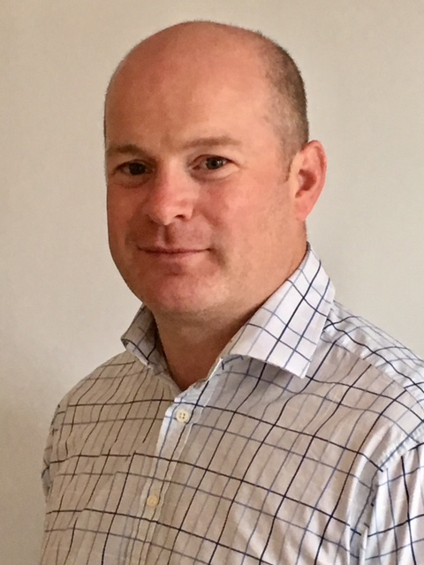



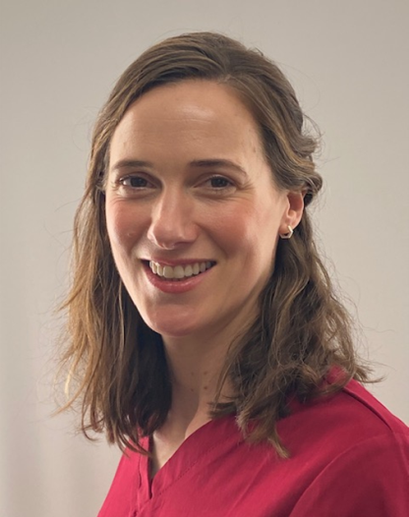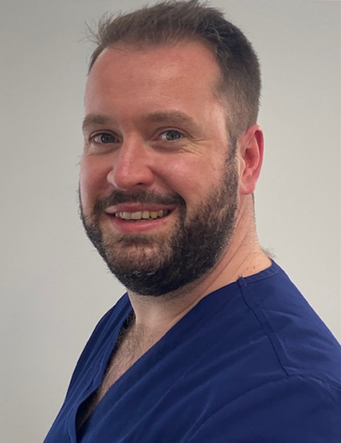

WELCOME
Marden Medical Practice welcomes you to
the Surgery and we hope that you find the
enclosed information useful.

Opening Hours:
8.00am – 6.00pm Monday to Friday.
Telephone Contact Number for Emergencies Only from
8.00am - 8.30am during lunchtime 1:00pm – 2:00pm and
6.00pm – 6.30pm only: 07980593370.

Out of hours:
If you require medical attention outside surgery hours,
Please contact 111 who will assess your needs and direct
you to the most appropriate service.

You can contact 111 at any time for medical advice.

For immediate paramedic assistance dial 999.

Consulting Times:
Appointments 8.30am – 6:00pm Monday to Friday.

Early Evening appointments are also available -
please telephone Reception for more details.

Welcome To Marden Medical Practice

We wish to thank you for registering with our Practice. The Partners and staff of this long-established practice are committed to providing the highest level of patient care.

You have the flexibility of consulting with either your registered doctor or any of the GPs in the practice. We offer a choice of mixed age, male or female doctors and therefore hope that we will be able to match your needs for a specific consulting style.

However, we recommend you see the same doctor for any ongoing problem to ensure continuity of care.

This booklet contains information about the facilities and services at the Practice and we hope you will find it useful and keep it handy for reference.

You can also gain updated information about the Practice from our website:
www.mardenpractice.gpsurgery.net

The Practice Team:

Doctors:

Dr L Houghton (Principal)
MB, BS, DCH, DROG, MRCGP

Dr C Ingram (Principal)
MBChB, DRCOG, MRCGP.

Dr E Baines (Principal)
MBBs, BSc, MRCPCH, DRCOG, MRCGP

Dr R Woollam (Principal)
BS, MB, MRCGP

Dr E May (Salaried)
BMedSc, MBChB, MRCGP

Dr L Hallam (Salaried)
MBChB, MRCGP, DRCOG, PGDip in Medical Education

Dr N Harrison (Salaried)
MRCGP

Dr T Maddox (Salaried)
MRCGP

Dr A Thomas (Salaried)
MRCGP

Practice Manager:
Zoe George

Business Manager
Joy Baker A.C.I.S

Patient Services Manager:
Debbie Turner

Reception Manager:
Kerry Robinson

The Practice has 10 Medical Receptionists and 5 Medical Administrators

Nursing Staff:

Ms Helen Hutton Advanced Nurse Practitioner
Mrs Gina Hughes Advanced Nurse Practitioner

Sister G Castling RGN, Dip N
Sister D Simcox RGN, Dip N
Sister J Dean RGN, Dip N
Sally Lockley HCA
Kimberley Bartley HCA

Other NHS Staff and Services within Marden:

Sally Lockley Community & Care Co-ordinator

PCN Clinician Physiotherapist

PCN Clinician Practice Pharmacist

PCN Clinician

NHS Trust Midwife / Health Visitor

Service and Clinics offered
Child 6 Week Check
Chronic Disease Management
Community Health Clinic
NHS Health Check
Family Planning including Coil & Implant Fittings
Health Care Assistant
Maternity Services
Minor Surgery / Minor Injuries
New Patient Health Checks
Phlebotomist
Physiotherapy
Travel Advice/
Adult & Child Immunisations Including Influenza Clinic
Weight Management
Woman’s Health Issues
Wound Care

Practice Manager
The Practice Manager is available to help with non medical aspects of your health and treatment. She is also available to discuss any suggestions or complaints.

Patient Services Manager

The Patient Services Manager can help with all Administration aspects within the Practice and is available to discuss any issues patients have within the Practice.

Reception Staff and Administration Staff
Our Reception Staff are here to help you. When telephoning for medical attention our Reception Staff may ask for a few details. The doctors have asked them to make these enquiries so that they can help you in the most appropriate way. Our Reception Staff have undertaken special training and always respect patient confidentiality.

Practice Nurse(s)
Practice Nurses are available by appointment for various treatments, health promotion advice and screening, including smears, immunisations and vaccinations.

The Nurses are qualified to advise and treat many minor conditions and it may prove quicker to see a Practice nurse than wait for a consultation with your doctor, who is always available if you have any cause for concern.

When booking an appointment with a Practice Nurse, our Reception Staff may need to ask you the reason for an appointment in order to determine how much time to allocate. Consultations are by appointment.

Health Care Assistant
Our Health Care Assistant’s are not qualified nurses, but they have undergone training to enable them to take bloods, blood pressure, assist with minor surgery, administering Flu Vaccines, smoking cessation advice, new patient health checks that do not involve medication, simple dressings, ear syringing, general heath checks and ECGs. All requests for blood tests must be made through one of the Doctors or Nurses.

District Nurses
District nurses assess, plan and manage the care of sick and disable patients of all ages in the patient’s own home, general practices and residential nursing homes and also provide support for their carers.

Individual care is planned, and advice on further help or services is given including health education. Anyone at home can self-refer to this service. They have a close liaison with the Hospital, GPs, the local hospice and other specialized services.

They administer drugs, give injections, dress wounds, take blood samples and give personal care.

The District Nurses are in regular contact with the Practice and messages may be left on 01743 277709

Emergencies
For life-threatening emergencies such as:
- Severe bleeding;
- Collapse or unconsciousness;
- Severe chest pains…
- Facial drop, Slurred speech, Loss of or weakness in arms/legs
…telephone 999 for an ambulance IMMEDIATELY.

Health Visitors
Health Visitors operate from Coral House, Longbow and are usually available by telephone on weekdays.

Their telephone number is 01743 452301.

Health visitors are qualified nurses and have additional training in child health and development, will monitor your child’s growth and development, answer any child health queries and help mothers to cope with children under five, advising on things like hygiene, safety, feeding and sleeping. They also hold special clinics or drop-in centres.

Health visitors can also provide you with help and information regarding such issues as emotional problems, relationship difficulties, family planning advice, health problems and advise on healthy eating, keeping warm and getting the right exercise.

Self Check-in
The surgery has an automated self check-in touch screen located in the foyer.

This is a simple to use system that enables the patient to check themselves into our appointments system.

Should you feel uncomfortable about using such a system, you can obtain help, or book in with our Reception Staff in the traditional manner.

Facilities at the Practice
We have:
- A room available for access by disabled people;
- A room available for nappy changing;
- A room available for breastfeeding;
- A room to discuss matters in private on request;
- A comfortable waiting area (our Practice is cleaned and checked every day).

We will keep you informed through:
- Our up-to-date Health and Practice information booklets;
- Notice boards in the waiting room;
- Local press, regular newsletters and the Practice website.

Home Visits
If you are unable to come to the surgery due to severe illness or frailty, please contact the surgery before 10am to arrange. Home visits take up much more of a doctor’s time than a consultation in the surgery, so if you are mobile please do come into the surgery to be seen.

Out of Hours
If you are in need of medical assistance when the surgery is closed please call 111 who will give advice or direct you to the appropriate service.

New Patients
The practice is able to take new patients that live in the Practice Area (as seen on Page Number 8).

To register, complete a registration form obtained from our Reception Staff or available on our website. Don’t worry if you do not have a Medical Card, our Reception Staff will still be able to register you and organise a full health check.

In the case of a new baby, bring their NHS Number (obtainable from Child Health or the Maternity Ward) or the child’s red book.

Please fill in our New Patient Health Questionnaire (downloadable from our website or available from our Reception Staff). Your medical record often takes a considerable time to arrive from your previous doctor and this gives us the opportunity of recording some basic information about you and offering you any immediate care you may need.

You will also need to bring a urine sample to this initial appointment. Please obtain a specimen bottle from our Reception Staff.

You will be registered with the Practice rather than a specific doctor, but you have a right to ask to see a particular doctor. You can ask to see a particular doctor when making an appointment. This will be accommodated where possible, but it may mean waiting longer for an appointment.

If you have a requirement for a prescription then you should arrange an appointment with a doctor of your choice to discuss your ongoing care.

If you have given a mobile telephone the Practice may contact you to remind you of appointments made and to ask you to attend appropriate health checks relating to any chronic disease you may have. Please ensure that you have ticked the relevant box on your registration form if you are happy for us to do this.

All new patients are encouraged to have a medical examination when registering with the Practice.

If you are taking any kind of medication, please make an appointment to see one of the Doctors

If not, you may see our Health Care Assistant instead.

We do not exclude patients from the Practice on grounds of age, sex, colour, race, nationality, ethnic or national origin or disability, sexual orientation, religion or religious or philosophical belief or medical condition.

NHS 111 service
NHS 111 operates a 24 hour nurse advice and health information service, providing information on:
What to do if you or your family are feeling ill
- Particular health conditions
- Local healthcare services, such as doctors, dentists or late night opening chemists
- Self help and support organisations

NHS Direct works in hand with other healthcare services provided by the NHS, helping you to make the right choice to meet your needs.

Calls to NHS 111 are charged at local rates and for patient’s safety all calls are recorded.

If you need health information or advice at any time of the day or night, please
contact NHS 111 by simply dialling 111.

Non-NHS Services
Patients should be aware that fees may be charged for services not covered by the NHS (e.g. private certificates, reports supporting private health insurance claims and other non-NHS medical reports).

Medical reports and examinations for life insurance are usually paid for by the insurance company requesting the examination.

Fees may be charged for services for other special purposes such as:
- HGV and PSV licences;
- Elderly drivers;
- Fitness-to-travel;
- Fitness-to-drive;
- Fitness-to-undertake certain sports: and
- Private Sick Notes
- Signing of Passport Application Forms.
- Holiday Cancellation Forms
- Insurance Forms
- Private Prescriptions

The fee-scale is recommended by the BMA and details are available on a poster in the waiting room, at Reception and on our website.

Patient UK
Patient UK is a reliable and comprehensive source of health and disease information, mainly aimed at the UK general public, but of interest to all.
This can be accessed by logging onto www.patient.co.uk

Disabled Access
Our surgery is accessible to patients using a wheelchair. We have automatic front door access suitable for wheelchairs, Disabled toilets and also designated car parking spaces which are reserved for patients displaying a disabled parking badge. We can accommodate patients on our ground floor level when they are visiting the practice to see any of our clinicians.

The Catchment Area
We have an open list and welcome requests for registration from patients living in or moving to the area.

The catchment area includes the following but is not limited to:
- Sutton Farm/Springfield
- Monkmoor
- Coleham
- Belle Vue
- Copthorne
- Bayston Hill
- Atcham
- Bicton Heath
- Sundorne
- Cross Houses
- Radbrook
- Upton Magna

The list is not exhaustive. If you are unsure whether you fall within our catchment area or not, please contact and a receptionist will be able to advise you.

You can register by coming along to the surgery and completing New Patient Registration Forms which include smoking status, alcohol consumption and a General Health Questionnaire. This registration form is also downloadable from our Practice Website.

We recommend that new patients undertake a Health Check with a Health Care Assistant.

Chaperones
Our Practice is committed to providing a safe, comfortable environment where patients and staff can be confident that best practice is being followed at all times and the safety of every-one is of paramount importance.

All patients are entitled to have a chaperone present for any consultation, examination or procedure where they feel one is required. This chaperone may be a family member or friend.

On occasions you may prefer a formal chaperone to be present.

Your healthcare professional may also require a chaperone to be present for certain consultations in accordance with our chaperone policy. If you wish to have a member of the Practice staff present during your consultation please mention this to our Reception Staff when booking your appointment, or to the doctor at your consultation, and it will be arranged.

Appointments
Our surgeries run as an appointment only system.

Non Urgent Appointments
Non urgent appointments can be made by telephoning the surgery or using the Patient Access System to book your appointment online. The surgery is open from 8.30am to take such calls. Patients will be booked in to see a doctor. Opening times are as page 1. You are able to book an appointment with a doctor of your choice up to 5 weeks in advance.

Patients who have not been seen at the practice for 3 years, and are between the ages of 16 and 75, may request a consultation during surgery hours for a general health check-up.

Patients aged 75 and over who have not been seen at the practice for 12 months may also request a consultation during surgery hours as above. Where it is considered inappropriate for the patient to attend the practice owing to their medical condition, this consultation will take place in the patient’s home.

Urgent Appointments
If you need to be seen urgently please contact the receptionists as early in the morning as possible, where you may be offered an appointment on the day. We sometimes hold what we call telephone triage where you may be offered a telephone call with a Doctor, who will return your call and advice whether you should come in to the surgery or give advice on what course of treatment is required.

Patient Access
For anonymity purposes and to safeguard your personal information, we would advise you to use the new Patient Access System for ordering your medication and booking routine Doctors appointments. You may also cancel these appointments online.

You need to register for this service, which is very simple and only takes a few minutes.

As well as ordering prescriptions, the system allows you to change personal details and leave the Practice a message online.

If you would like to register for Patient Access, please ask a member of the Reception team for a registration form.

Repeat Prescriptions
Repeat prescriptions can be requested as follows:
- Call the Prescription Ordering Direct Team on 0333 358 3509.
- Post your request to the surgery.
- Call into the surgery in person.
- Patient Access System
- NHS App

RECEPTIONISTS ARE NOT AUTHORISED TO ACCEPT REPEAT PRESCRIPTION REQUESTS VIA THE TELEPHONE.

All prescription requests take 2 working days to be processed.

Prescription Collection Service

If you take medication on repeat prescriptions, you may wish to take advantage of a free service offered by all local Pharmacies.

They offer to collect prescriptions from the surgery and have the medication readily available for collection at an agreed time at their premises.

In some circumstances, they may also be prepared to deliver (e.g. to the elderly, disabled or housebound).

If you wish to take advantage of this service, you can find out which pharmacies participate by phoning your usual pharmacy or asking our Reception Staff.

Please complete the form below and pass it to the pharmacy of your choice and then when you need repeat medication in future, order the medication from the surgery and the pharmacy will be able to arrange collection.

--------------------------------------------------------------------------------------------------------------------

FREE PRESCRIPTION COLLECTION SERVICE

I am authorising the pharmacist at __________________________________Pharmacy to pick up my repeat prescriptions from the surgery and then have them ready for me to collect.

Patient’s Name: _________________________________

Address: ______________________________________________________________________

______________________________________________________

Post Code: _______________________

Telephone: ______________________ Signature: ___________________________

Marden Medical Practice
25, Sutton Road
Shrewsbury
Shropshire
SY2 6DL

Sickness Certificates
Under current legislation a Patient can “self certificate” for the first 7 working days of any illness. The self certificate (Form SC2) is available from the DSS office or your employer. We do not issue doctors certificates for the first week. If your employer requests a certificate, we have a standard letter that can be collected from Reception explaining to your employer that our doctors do not certificate for the first week.

After the first week, if you require a free Statement of Fitness for Work (Fit Note), please make an appointment as these are obtained as part of a consultation with a doctor.

Form SC1 (Incapacity Benefit Claim Form) is available from this Practice for people who have an illness or disability and are unable to work. People who are in work but require special medical treatment (e.g. dialysis, radiotherapy, chemotherapy) may also be eligible for this benefit.

If you require one for insurance or other purposes, please ask your doctor (a fee will be payable in this instance – details are available on a poster in the waiting room, at reception and on our website).

Social Services – Some Useful Information
Social Services is a department of Shropshire County Council which provides information about, and access to, a wide range of social care services for people in need. Such services include care at home services, day care, respite care and long-term residential and nursing home care.

Services are provided directly by the County Council or by arrangement with the private or voluntary sector. The staff you are likely to be in touch with will include social workers, occupational therapists, home care assistants and day service workers.

Access to services is subject to assessment by Social Services staff who will take into account your views as well as information from any health professionals or others involved in your care and will often include financial assessment as some services are charged for.

If you meet the criteria which establish your eligibility for a service, a care plan will be agreed with you and the services available are:

Social Services for Adults aim to:
- Maintain an individual’s ability to live independently in the community;
- Provide relief for family carers;
- Enable provision of residential and nursing home care when independent living is not possible.

The Main Types of Services are:
- Information and advice;
- Domiciliary services;
- Home care (for help with personal care such as washing and dressing). Help with housework and shopping is given where there are personal care needs, or to relieve a family carer;
- Carer support;
- Equipment or adaptations to property to enable independent living with advice from occupational therapists;
- Day services;
- Residential or Nursing Home Care;

How Do You Get Help?

Contact your local area office who will be happy to advise about the help available.

Useful Telephone Numbers

Telephone Numbers for the Local Offices for Shropshire Area: 0345 678 9005

Social Services are available to offer help and assistance to carers and can be contacted on: 01743 255849 (Elderly) 01743 253600 (Children)

Staff Training
Three afternoons a year the Practice is closed so that doctors, nursing staff and admin staff can attend essential training.

The aim of the training is to allow doctors and staff protected time for Continued Professional Development (CPD).

These closure dates will be advertised in Reception and on the Practice Website.

Telephone Answer Times
We will aim to answer the telephone within five rings.

If you need to speak to a doctor / nurse in an emergency we will endeavour to put you through as soon as they are available.

If this is not possible, the doctor / nurse will return your call as soon as reasonably practicable after receiving your message.

Temporary/Short-Term Resident
We provide a Temporary Patient service for anyone staying within our Practice area (e.g. whilst on holiday, staying with relatives etc.)

Just call into the Surgery, obtain a Temporary Resident Form from our Reception Staff, return it to us completed and we will be happy to assist you.

Consent for Children’s Treatment (Under the Age of 16)
Where it is considered appropriate by parents, or where an adolescent does not wish the presence of an adult, a child may give the legal consent to their own treatment.

Under these circumstances, the clinician must be satisfied that the child has a full understanding of the advice and treatment being provided.

Change of Personal Details
If you change name, address or telephone number, please let our receptionists know in writing. There are forms at reception for patients to complete. It is the patients’ responsibility to ensure that we hold up to date information.

If you move outside our practice area you may be advised that you need to join another practice in your area. If you are unsure, please ask one of the receptionists. Details of practices in your area are held by CCG Trust who can be contacted on 01743 277500 and ask for the Registrations Department.

Immunisation Time-Table
Many potentially fatal childhood diseases have been virtually eradicated in the UK due to the availability of vaccinations. It is very important that all children are fully immunised. Reminders are sent out by the Health Authority.

Current recommendations are:

2 months 1st Diphtheria, tetanus, whooping cough, polio & HIB injection (5 in1)
1st Pneumococcal
1st Rotarix
1st Meningitis B

3 months 2nd Diphtheria, tetanus, whooping cough, polio & HIB injection (5in 1)
2nd Rotarix

4 months 3rd Diphtheria, tetanus, whooping cough, polio & HIB injection (5 in1)
2nd Pneumococcal
2nd Meningitis B

12 months 1st MMR (Measles, Mumps & Rubella)
HIB/ Men C
3rd Pneumococcal
3rd Meningitis B

3yr 4 months Booster diphtheria, tetanus, whooping cough & polio injection
2nd MMR (Measles, Mumps & Rubella)

13 – 17 years Booster Diphtheria, tetanus & polio injection - GIVEN ATSCHOOL
Meningococcal ACWY booster- GIVEN ATSCHOOL
HPV – GIVEN AT SCHOOL

Tetanus may develop in wounds picked up in the garden. We recommend that everyone has a booster every 10 years up to the maximum of five vaccines (With the exception of a booster given for travel or occupational health purposes).

Test Results
You may contact the surgery to receive the result of any tests you may have had. Please allow 5 days for blood results and 10 days for X-rays and scans.

We are only allowed to give out test results to the patient or to parents of children under 16 years of age. Should you wish your result to be given out to someone else, you must contact the surgery and advise accordingly.

Telephone Advice/Calls from a Clinician
Clinicians are available (normally between 11:00am – 14:00pm) to give telephone advice after their morning surgery. Patients are advised to telephone before 10:30am to arrange this.

Research / Surveys
The Practice participates in studies and surveys to improve Patient Care and we are also externally evaluated as a training Practice and for re-accreditation of nationally recognized quality awards.

Qualified assessors come into the Practice and are bound by the same stringent rules of confidentiality as are all members of the NHS.

You may be asked to complete questionnaires from time to time but you have our assurance that these will be handled in an entirely confidential manner, as is all Patient-related data.

Your participation in any aspect of external evaluation or research is optional.

Training Practice
The surgery has been accredited as being suitable as a training practice for those Doctors intending to become GPs and is proud to have offered this service for a number of years. We also teach Medical Students.

The GP Registrar (the Trainee) is a fully qualified doctor who already has much experience of hospital medicines and who will gain invaluable experience by being based within the Practice. They work full-time in the practice for a period of 6 or 12 months.

At all times they provide care of the same standard as that provided by the other doctors – please accept them as a valued addition to our team.

Consultations are sometimes videoed for training purposes. You will be notified beforehand if this is the case and will be asked to sign a consent form. The recording will only take place if you agree to this; there is no obligation for you to do so.

You may be asked whether you are willing to see your doctor in the presence of a student.

Occasionally, patients may be invited to discuss their symptoms with the medical student alone, prior to further consultation and treatment with the doctor. Again you are free to refuse.

A notice will also be provided at the Reception Desk when medical students are present in the Practice for training.

Carer’s Register
The Practice has a Carer’s Register for people who care for a relative/friend. Carer’s Information Packs are available from our Reception Staff and there is a Carer’s Board in the Waiting Room.

Mobile Phones
We allow mobile phones to be used within the surgery building, but please ensure they are put on silent whilst in the waiting room and turn them off before going into the doctor's consulting room.

Patient Participation Group
Are you interested in having a say about healthcare matters?

Do you have some free time to attend meetings?
OR
Would you like to be part of an e-mail consultation group with whom we can consult on healthcare matters?

New members are always welcome to join our active Patient Participation Group or Patient Reference Group - please ask our Patient Services Manager for more details.

Safety and Security
The Practice has CCTV installed at the Practice premises.

In keeping with our commitment to providing the best possible service to all our patients, we hope the CCTV installation will provide assurance to patients & staff that safety and security are high on our agenda.

We uphold our policy that all consultations are private and confidential therefore please be assured that no monitors have been installed in any of the consulting rooms.

Patients’ Rights and Responsibilities
Patient records are safe with us – we ask for information about patients so that they receive the best possible care. Unless there are exceptional circumstances, for example when the health and safety of others are at risk, we will not disclose your information to third parties without your permission.

Everyone working for the NHS has a legal duty to maintain the highest level of confidentiality about patient information. In some instances you may well be receiving care from other people as well as the NHS. In this instance we may need to share some information about you with them so that we can all work together for your benefit.

In certain circumstances we are required by law to report information to the appropriate authorities: however our guiding principle is that we are holding your records in strict confidence.

If at any time patients would like to know more about how we use their information patients can speak to the Managing Partner.

Car Parking
A car park is provided for patients who are visiting the surgery, with designated parking spaces for the use of disabled patients and for parent and child.

Please park only in the spaces provided and ensure you are not blocking the exit of a doctor who may be called out on an emergency.

Please note that no responsibility can be accepted by the Practice for damage caused to any vehicle using the car park.

PRACTICE CHARTER
These are local standards set within this Practice for the benefit of our patients.

Our Responsibilities to you.
- You will be treated with courtesy and respect by all Practice personnel.
- An urgent appointment with a Doctor or Nurse Practitioner will be available on the same day.
- A non-urgent appointment with a doctor will be offered within 3 working days
- We aim to answer the telephone within six rings.
- An appointment with a Practice Nurse will be available within three working days.
- Requests for repeat prescriptions will be dealt with within 48 working hours. This can be in person, by fax, email, post or by asking a local Pharmacy to order it on your behalf.
- All comments and suggestions about the service are welcome. Please use the box provided in the waiting area.
- If you have a complaint please speak to any member of staff. Your complaint will be dealt with in a professional and efficient manner.
- We wish to make the Practice as accessible as possible. If you have hearing, visual or physical difficulties please let our Reception Staff know, so that we can enable you to fully use our services.

Your Responsibilities to us..
- If you are unable to attend for an appointment please let us know so that we can offer it to someone else.
- If you are late for your appointment you may be asked to rebook at another time. Try to let us know in advance if you are going to be unavoidably delayed, so that we can make alternative arrangements to help you.
- A home visit should only be requested for those who are unable to come to the surgery because of serious illness or infirmity. Please ring the surgery before 10:00am if at all possible.
- An urgent appointment is for an urgent medical problem. Please speak to our Reception Staff if you require a sick note or repeat prescription.
- We would ask you to be patient if the Doctor is running late. This is often due to unforeseeable emergencies but please ask for an explanation from the Receptionist.
- Make a separate appointment for each patient that needs to be seen. This allows the Doctor enough time to treat each patient with the time that they deserve.
- Please act in a responsible and courteous manner whilst on the Practice premises for the safety and comfort of others.
- Please treat all surgery staff, fellow patients, carers and visitors politely and with respect. Violence or verbal harassment will not be tolerated or accepted.
- If you are violent or abusive, you will be warned to stop their behaviour. If you persist, we may exercise our right to take action to have you removed, immediately if necessary, from our list of patients and asked to register at another surgery. In some cases, where necessary, the Practice will involve the police.
- While we strive to meet the standards in this charter, we will also need your help to achieve this by following the actions given by your clinician and taking the correct medications promptly.

GDPR (Genera Data Protection Regulations)
All information held about patients is completely confidential. The Practice is registered under the GDPR 2018. This Act protects data held by the practice.

The GDPR replaces the Data Protection Directive 95/46/EC and is designed to harmonise data privacy laws across Europe, to protect and empower all EU citizens’ data privacy and to reshape the way in which organisations across the region approach data privacy. The GPDR came into effect on 25 May 2018.

For a full copy of our Privacy Notice, please visit our Practice Website: https://mardenpractice.gpsurgery.net

SAR (Subject Access Requests) & SAR (Subject Access Requests)
You have a right to access the information we hold about you. If you would like to access this information, you will need to complete a Subject Access Request (SAR). Please ask at reception for a SAR form and you will be given further information. Furthermore, should you identify any inaccuracies; you have a right to have the inaccurate data corrected.

Opting Out
If you are happy for your data to be extracted and used for the purposes described in our Privacy Notice then you do not need to do anything. If you do not want your information to be used for any purpose beyond providing your care you can choose to opt-out. If you wish to do so, please let us know so we can code your record appropriately. We will respect your decision if you do not wish your information to be used for any purpose other than your care but in some circumstances we may still be legally required to disclose your data.

The Freedom of Information Act gives you the right to request information held by a public sector organisation. Unless there is good reason, the organisation must provide the information within 20 working days. Please contact the Reception Manager if you require further information.

Zero Tolerance
We always aim to treat our patients with courtesy and respect. We ask that you treat out staff in the same way. We operate a zero tolerance policy towards violent and abusive behaviour. Any occurrence of such behaviour towards practice staff or other patients may result in the patient being removed from the practice list. The practice reserves the right to call the police for assistance.

Confidentiality
All staff in the Practice are bound contractually to maintain Patient confidentiality and any proven breach of this will be treated extremely seriously.

We respect your right to privacy and keep all your health information confidential and secure. Confidentiality also extends to Patients’ family members. Medical information relating to you will not be divulged to a family member or anyone else, without your written consent.

As we are a computerised Practice, all our patient records are kept on computer and can assure patients of complete confidentiality.

Your rights are protected as we are registered under the General Data Protection Regulations 2018.

It is important that the NHS keeps accurate and up-to-date records about your health and treatment so that those treating you can give you the best possible advice and care.

However, for the effective functioning of a multi-disciplinary team it is sometimes necessary that medical information about you is shared between members of the practice team.

The patient‘s rights in relation to disclosure of such information are covered by the Practice‘s registration under the General Data Protection Regulations 2018 and we follow the guidance issued by the GMC in ‘Confidentiality: Protecting and Providing Information’ which explains circumstances in which information may be disclosed.

This information is only available to those involved in your care and you should never be asked for personal medical information by anyone not involved in your care.

You have a right to know what information we hold about you. If you would like to see your records, please speak to the Reception Manager (please not that there will be a charge for this information).

We have a dedicated leaflet on General Data Protection – please ask our Reception Staff for a copy.

Integrated Care System
The new ICS website is now live. The website address is Home - NHS Shropshire, Telford and Wrekin (shropshiretelfordandwrekin.nhs.uk).

Comments & Complaints
We welcome your views and constructive suggestions which will help us improve our service to you. There is a suggestion / comments box located in the foyer for this purpose.

If you have a complaint about the service you have received from any of the staff working at this Practice, please let us know.

We operate a Practice complaints procedure as part of the NHS system for dealing with complaints. Our procedure meets national criteria.

We hope that most problems can be sorted out easily and quickly, preferably at the time they arise and with the person concerned.

If your problem cannot be sorted out in this way and you wish to make a complaint, we would like you to let us know as soon as possible, ideally within a matter of days as this will enable us to establish what happened more easily.

Complaints should be addressed to the Practice Manager – Mrs Zoe George

Alternatively, you may ask for an appointment with the Practice Manager in order to discuss your concerns.

She will explain the complaints procedure to you and will ensure your concerns are dealt with promptly. It will be a great help if you are as specific as possible about your complaint.

We shall acknowledge your complaint within three working days and aim to have looked into your complaint within a reasonable timescale of the date when you raised it with us.

We shall then be in a position to offer you an explanation, or a meeting with the people involved. When we look into your complaint, we shall aim to:

- Find out what had happened and what went wrong;
- Agree a plan on how your complaint will be dealt with and the timescales involved;
- Make it possible for you to discuss the problem with those concerned, if you would like this;
- Make sure you receive an apology where that is appropriate;
- Identify what we can do to make sure the problem doesn’t happen again

Useful Telephone Numbers

Alcoholics Anonymous 01952 270616
Breast Cancer Care 0808 800 6000
Childline 0800 1111
Childline Minicom 0800 400 222
Citizens Advice Bureau 01743 357855
Community Health Council 01743 235261
Cruse (Bereavement) 01743 241882
District Nurses 01743 264090
Drugsline (Antidrug campaign) 0800 526475
Health Visitors 01743 452301
Hospice 01743 236565
NSPCC 0800 800 500
Nuffield Hospital Shrewsbury 01743 282500
PALS 0800 0321107
Police 01743 232888
Primary Care Trust 01743 261300
Royal Shrewsbury Hospital 01743 261000
Samaritans 01743 369696
Shropshire County Primary Care Trust 01743 277500
Substance Misuse 01952 222229

Pharmacies
Asda 01743 276810
Boots Meole Brace 01743 236973
Boots Pride Hill 01743 351311
Boots Copthorne 01743 350747
Conway 01743 352352
Lunts Riverside 01743 344523
Lunts Hereford Road 01743 351918
Lunts Roushill 01743 232857
Rhodes 01743 343998
Rowlands Bayston Hill 01743 872154
Rowlands Sutton Farm 01743 369446
Rowlands Severnfields 01743 462929
Sainsburys Lloyds 01743 365536
Taylors Radbrook 01743 249931
Tesco Harlescott 01743 501000
Taylors Bicton 01743 249129
Well 01743 344277

