PATIENT PARTICIPATION GROUP
To all of you affected by or living with Dementia,

Dear Patient and Carers

The Staff at Marden are holding an extensive display during Dementia Action Week -
17th to 23rd May 2021 at the Surgery. This is to raise awareness of Dementia and encourage everyone to be understanding and supportive of all those who are living with and those who are affected by Dementia.
The Patient Participation Group at Marden is very conscious of the challenges you have no doubt faced during this difficult year due to Covid-19.

We would like you to know that now things are beginning to get back to ‘normal’ we hope that we will hear from you to let us know how you would like our group to support you.

The last 12 months for us:
Keeping in touch with friends and family by telephone, FaceTime and Zoom have been very important. Pastimes and hobbies have played a big part in keeping us occupied and giving each other time and personal space.

The biggest downside has not being able to see family and friends in person but not too long to go now!!!

A little more tolerance and patience than usual has come in very handy.

Best wishes to you all,
Clive and Barbara Rogers
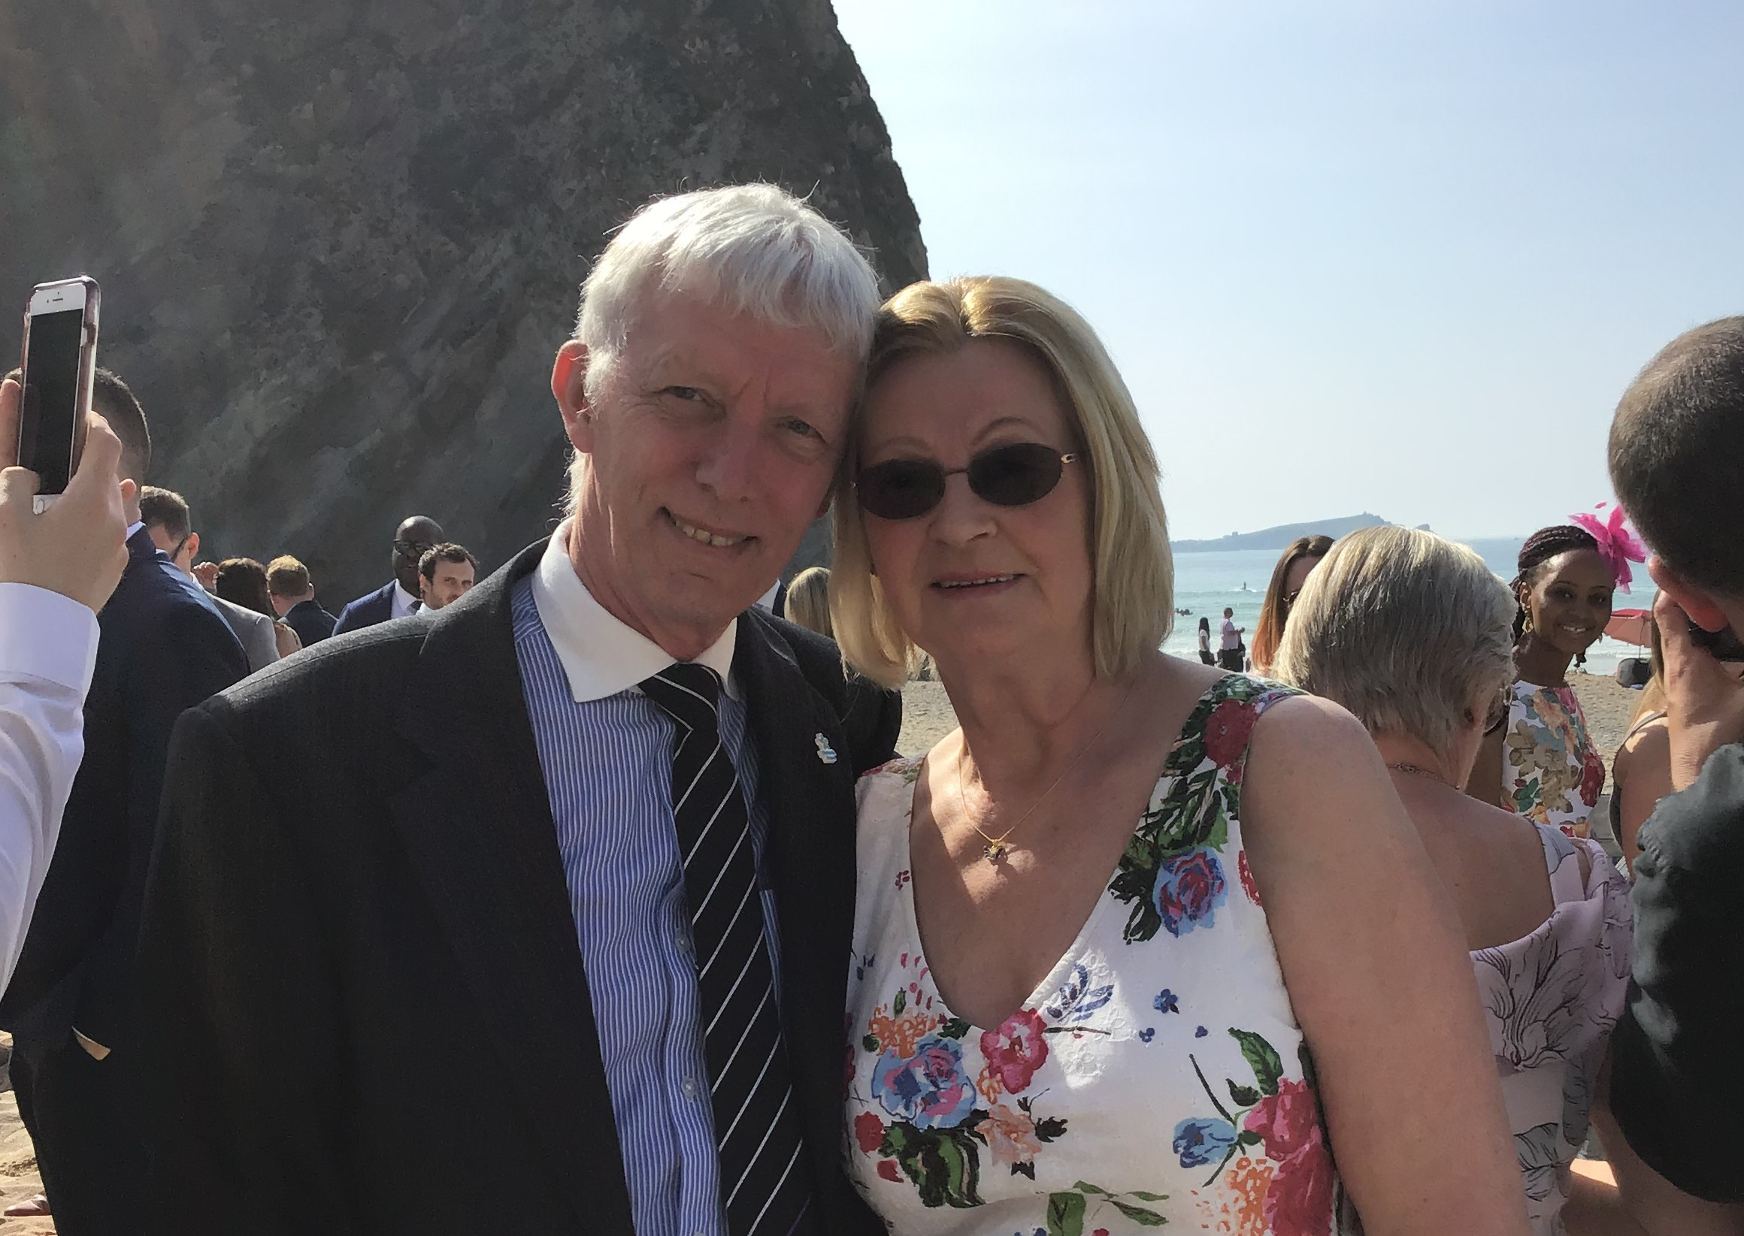
(Clive is a Dementia friend living with dementia and his wife Barbara, who is also a friend, is alongside him all the way as his constant companion and carer).

THANK YOU

KEY WORKERS:
CARERS
FRIENDS FAMILY
NEIGHBOURS

NHS
DOCTORS NURSES
ALL HOSPITAL
AND PRACTICE STAFF
SUPERMARKETS/
SHOPPERS
AND MANY MORE

These may be some of the things that you have been coping with which we hope will begin to get better.
LONELINESS LOSS
ISOLATION
GRIEF ANXIETY
FEAR

And more besides

DO GET
IN TOUCH
We would like to hear from you!

Here is some information from:
Shropshire Telford and Wrekin Dementia Action Alliance:
We’re just trying to sign off on a booklet of resources across the county
for people living with dementia….LOOK OUT FOR IT

PATIENT PARTICIPATION GROUP, MARDEN MEDICAL PRACTICE, 25 Sutton Road, Shrewsbury SY2 6DL
TEL: 01743 241313 Email: marden.marden@nhs.net Web: www.mardenpractice.gpsurgery.net

