Social Prescription

Social Prescribing is available in this GP Practice.

Social Prescribing is a non-medical programme, which enables people to access services and support in their own communities with the help of a trained Advisor.

The Advisor helps people understand their health and wellbeing needs, supports them in setting realistic goals and develops an action plan to achieve these.

Many people can benefit from Social Prescribing. This includes those who may be….

Caring for someone who can’t manage without this help
Living with a Long-Term Health
Condition

Feeling worried or anxious

Feeling lonely or socially isolated
Wanting to change their lifestyle e.g. giving up smoking or losing weight

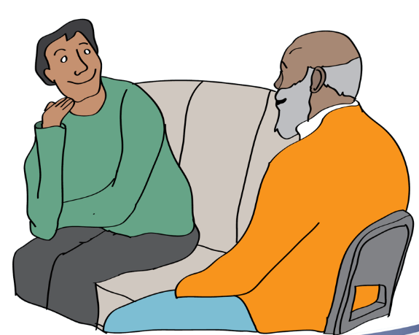
Your Practice feels this is something that could work well for you, and following a discussion with you, will arrange an appointment with a trained Social Prescribing Advisor.

Please turn over to find out more

For GP Practice use:
Please tick as appropriate

Appointment made

Referral made

Please give this leaflet back to the patient, so they have the information overleaf, and ask them to book their appointment at reception if you have not already made an appointment for them.

Please add in their consultation "referred to social prescribing" (there is a Read Code for that so start typing "social prescribing" then “referred to social prescribing “shows as an option) and also add the reason for referral to assist the Advisor and for monitoring.

Social Prescribing

I have been referred for Social Prescribing. What is it and what happens next?

Your GP/Nurse or Surgery has given you a prescription of a different kind. Social Prescribing is a non-medical programme, which enables you to work with a trained advisor to develop your own plan to improve your health and wellbeing, and to access services and support in your own community.

What happens next?

- Usually, an appointment with a Social Prescribing Advisor will have been booked for you at your GP Practice. Otherwise, the Social Prescribing Advisor will contact you directly and arrange an appointment with you.
- When you and the Advisor meet, you will decide together what will support you best.
What happens at the appointment and afterwards?

- You and the Advisor will meet one to one, for about an hour, to discuss your health and wellbeing and develop your action plan. This may involve attending a community group or activity in your local area. The Advisor will keep in touch with you and offer further support as needed.
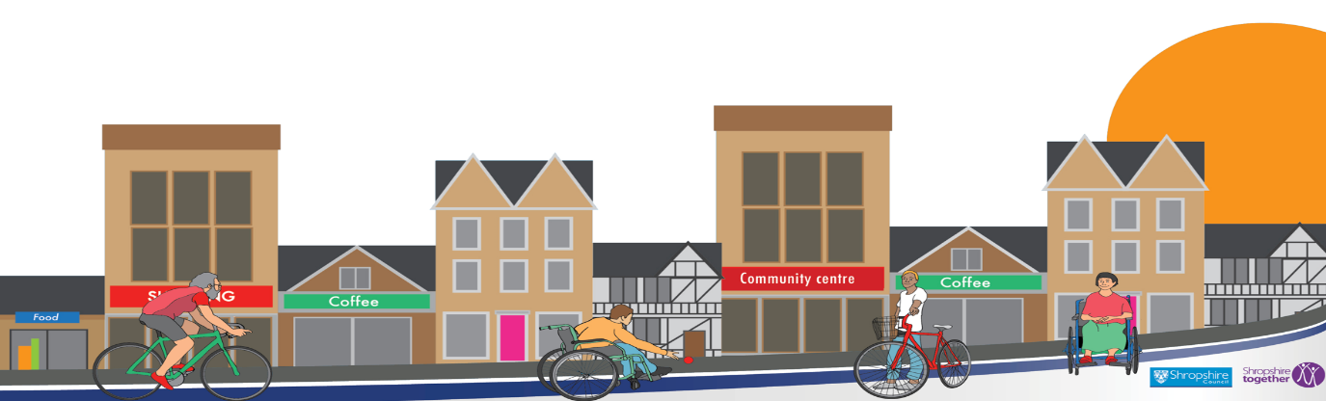
You can bring a family member or someone you trust to the appointment with you, or come on your own. It’s up to you.
“Do it! Don’t be afraid to ask for help and accept the help of others, you are stronger for asking! It takes a strong person to admit that they need help”

“What have you got to lose? You don’t have to take their advice but you should! They really know what they are talking about… seeing (the advisor) really turned my life around”

What do people say who have used the service?

