**Received by**

**Today’s Date:**

**Marden Medical Practice**

**New Patient Registration Form**

Please complete this confidential Registration Form in BLOCK CAPITALS and tick the appropriate boxes.

It is important to inform us if any of these details change in the future.

A separate form needs to be completed for each family member registering with us.

**DEMOGRAPHICS**

**Male Female**

**Mr Mrs Miss Ms Other**

**Full Name:**

**Previous /Mother’s surname if different:**

**Date of Birth: NHS No.**

**Town & Country of Birth:**

**Home Address:**

**Postcode: Tick if you are homeless:**

**Housing: House Flat Maisonette Mobile Home**

**Your Occupation**:

**Home Telephone Number:**

**Work Telephone Number:**

**Mobile Telephone Number:**

**Email Address:**

**Please tick to confirm that you are happy for us to use all the above methods, i.e. home*/mobile*/email*/address* for contacting you in relation to appointment invites/cancellations, repeat prescription requests, information about our services ONLY . * Delete as necessary**

**Name and Ages of all your other Household Members**:

**Name of Next of Kin:**

**Relationship to Patient:**

**Contact Information:**

**Are you happy for us to contact them in an Emergency? Yes No**

**Are they a patient at Marden Medical Practice? Yes No**

**If Patient is Under 16 Years Old**

**First Language of Parent/Carer:**

**Is the Child in the Care of: Local Authority Adopted Fostered**

**School Attending**:

**Ethnic Origin**

**White – British White – Other**

**Black – African Black – Caribbean**

**Black – Other Asian**

**Mixed Race Other**

**Religion**

**C of E Catholic Jehovah’s Witness**

**Buddhist Hindu Muslim**

**Sikh Jewish No Religion**

**Other Religion**

**Your Main or 1st Language Spoken/Understood:**

**PLEASE NOTE – Previous Address and Doctor MUST be Completed**

**Your Previous Address:**

**Postcode:**

**Previous Doctor’s Information**

**Doctor’s Name:**

**Surgery Address:**

**Postcode:**

**If you are from abroad and have NOT lived in the UK before**

**Date you first came to live in Britain:**

**Is this your first UK Doctor’s registration? Yes No**

* **If you have registered with a UK doctor before, please fill in the last doctor’s name and address details above**
* **If you have newly arrived in the UK, please bring your passport to confirm your date of birth and entitlement to NHS treatment**

**Do you need a language interpreter? Yes No**

**What is your first choice of language?**

**Consent for carer or family member to interpret: Yes No**

**SUPPLEMENTARY QUESTIONS**

**PATIENT DECLARATION for all patients who are not ordinarily residents in the UKn the UK**

Anybody in England can register with a GP practice and receive free medical care from that practice.

However, if you are not ‘ordinarily resident’ in the UK you may have to pay for NHS treatment outside of the GP practice. Being ordinarily resident broadly means living lawfully in the UK on a properly settled basis for the time being. In most cases, nationals of countries outside the European Economic Area must also have the status of ‘indefinite leave to remain’ in the UK.

Some services, such as diagnostic tests of suspected infectious diseases and any treatment of those diseases are free of charge to all people, while some groups who are not ordinarily resident here are exempt from all treatment charges.

More information on ordinary residence, exemptions and paying for NHS services can be found in the Visitor and Migrant patient leaflet, available from your GP practice.

**You may be asked to provide proof of entitlement in order to receive free NHS treatment outside of the GP practice, otherwise you may be charged for your treatment. Even if you have to pay for a service, you will always be provided with any immediately necessary or urgent treatment, regardless of advance payment.**

**The information you give on this form will be used to assist in identifying your chargeable status, and may be shared, including with NHS secondary care organisations (e.g. hospitals) and NHS Digital, for the purposes of validation, invoicing and cost recovery. You may be contacted on behalf of the NHS to confirm any details you have provided.**

**Please tick one of the following boxes:**

1. 🞏 I understand that I may need to pay for NHS treatment outside of the GP practice
2. 🞏 I understand I have a valid exemption from paying for NHS treatment outside of the GP practice. This includes for

example, an EHIC, or payment of the Immigration Health Charge (“the Surcharge”), when accompanied by a valid visa. I can provide documents to support this when requested

1. 🞏 I do not know my chargeable status

I declare that the information I give on this form is correct and complete. I understand that if it is not correct, appropriate action may be taken against me.

**A parent/guardian should complete the form on behalf of a child under 16.**

|  |
| --- |
| **Signed:** |

**Date:**

**Print name:**

**Relationship to**

**patient:**

**On behalf of:**

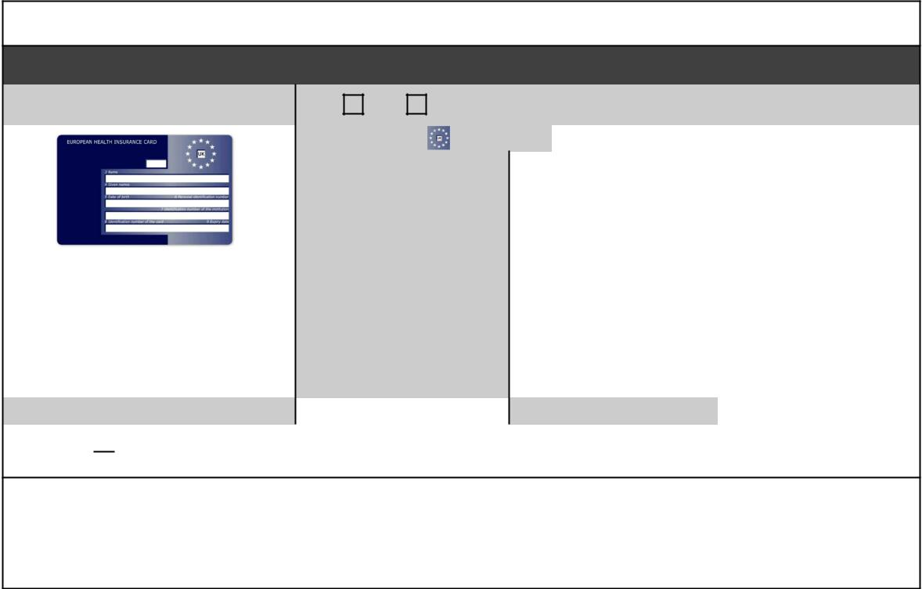

**Complete this section if you live in another EEA country, or have moved to the UK to study or retire, or if you live in the UK but work in another EEA member state. Do not complete this section if you have an EHIC issued by the UK.**

**NON-UK EUROPEAN HEALTH INSURANCE CARD (EHIC), PROVISIONAL REPLACEMENT CERTIFICATE (PRC)**

**DETAILS and S1 FORMS**

|  |  |  |  |  |  |
| --- | --- | --- | --- | --- | --- |
| Do you have a non-UK EHIC or PRC? | | | **YES:** | **NO:** | If yes, please enter details from your EHIC or |
| PRC below: |
|  |  |  |  |  |
|  |  |  | Country Code: | |  |
|  |  |  |  |  |  |

|  |  |  |  |  |  |
| --- | --- | --- | --- | --- | --- |
|  |  | 3: Name |  |  | |
|  |  |  |  |  | |
|  |  | 4: Given Names |  |  | |
|  |  |  |  |  | |
|  |  | 5: Date of Birth | DD MM YYYY | | |
|  |  |  |  |  | |
|  |  | 6: Personal Identification |  |  | |
| *If you are visiting from another EEA* | | Number |  |  | |
|  |  |  | |
| *country and do not hold a current* | | 7: Identification number |  |  | |
| *EHIC (or Provisional Replacement* | | of the institution |  |  | |
| *Certificate (PRC))/S1, you may be billed* | |  |  |  | |
| 8: Identification number |  |  | |
| *for the cost of any treatment received* | |  |  | |
| of the card |  |  | |
| *outside of the GP practice, including* | |  |  | |
|  |  |  | |
| *at a hospital.* |  | 9: Expiry Date | DD MM YYYY | | |
|  |  |  |  | |  |
| PRC validity period | (a) From: | DD MM YYYY | (b) To: | | DD MM YYYY |
|  |  |  |  | |  |

Please tick 🞏 if you have an S1 (e.g. you are retiring to the UK or you have been posted here by your employer for work or you live in the UK but work in another EEA member state). **Please give your S1 form to the practice staff**.

**How will your EHIC/PRC/S1 data be used?** By using your EHIC or PRC for NHS treatment costs your EHIC or PRC dataand GP appointment data will be shared with NHS secondary care (hospitals) and NHS Digital solely for the purposes of cost recovery. Your clinical data will not be shared in the cost recovery process.

Your EHIC, PRC or S1 information will be shared with The Department for Work and Pensions for the purpose of recovering your NHS costs from your home country

**IF YOU ARE RETURNING FROM THE ARMED FORCES**

**Service or Personnel No.:**

**Your Enlistment Date:**

**Your Leaving Date:**

**Address at which you lived before joining the forces:**

**Postcode:**

**Name and Address of your Last Doctor Before Joining the Forces**

**Doctor’s Name:**

**Surgery Address:**

**Postcode:**

**Force Served: Army RAF Royal Navy**

**Are you a Military Veteran? Yes No**

**IF YOU ARE RETURNING TO THE UK FROM LIVING ABROAD**

**Country Returning From:**

**Date Left the UK:**

**Date Returned to the UK:**

**Address Prior to Leaving the UK:**

**Postcode:**

**Name and Address of your Last Doctor Before Leaving the UK**

**Doctor’s Name:**

**Surgery Address:**

**Postcode:**

**Do you have a “Living Will” (a statement explaining what medical treatment you would not want in the future)?**

**Yes No**

**If YES, please can you bring a written copy of it your New Patient Consultation.**

**Have you nominated someone to speak on your behalf (e.g. a family member or a person who has Power or Attorney**

**Yes No**

**If YES, please ask a member of the reception team for a Third Party Consent Form.**

**Do you have a Power of Attorney Yes No**

**If you have a Power of Attorney for Health & Welfare please provide us with a copy for our records.**

**If you are a carer please provide the following information for the person you care for:**

**Name:**

**Address:**

**Postcode:**

**Phone Number:**

**If you have a Carer:**

**Please fill in Carer details below**:

**Carer’s Name:**

**Carer’s Address:**

**Postcode:**

**Telephone Number:**

**Relationship to you:**

**Is this your main carer? Yes No**

**Is this a professional carer? Yes No**

**Should we contact you via your carer? Yes No**

**Have you been diagnosed with dementia? Yes No**

**For office use - (If unpaid carer, please pass details to carers champion. For professional carers please add details to patient registration family relationship links and add carers alert)**

**If you wish to be contacted by a method not mentioned please give details:**

**Specific Needs**





**Are you an “Assistance Dog” user? Yes No**

**Please state any requirements you have to be able to access the Practice premises:**

**Please state any Religious or Cultural needs:**

**Please state any specific nutritional requirements you have:**

**Please state any Phobias you have:**

**Accessible Information Form:**

Please inform the surgery of any changes to your **needs** in the future.

**Do you need us to contact you in a certain way or need information in a certain format?** (Examples include using a British Sign Language interpreter, deafblind interpreter, using a hearing aid, needing documents in large print, easy read or braille etc.)

**Yes No**

**If Yes** please continue to answer the questions below

**If “No”** please continue filling in form from “end of questions on communication and information needs”

**How should we contact you?**

**Does not need to be contacted using a particular method** (i.e. can accept BOTH standard letters AND telephone calls)

**Who do you need to help you when you see us?**

**Does NOT need professional communication support/interpreter**

Carer/support worker/family member who knows me well

Family member was present when this form was completed

Professional advocate

British Sign Language (BSL) Interpreter

Hands-on-signing Interpreter

Sign Supported English (SSE) Interpreter

Visual Frame Interpreter

Lipspeaker

Notetaker

Speech-to-text Reporter

Deafblind Communicator Guide

Deafblind Intervener

Deafblind Haptic Communication Interpreter

Deafblind Block Alphabet Interpreter

Deafblind Manual Alphabet Interpreter

Makaton Sign Language Interpreter

Needs other communication support not listed here (Please provide details):

**How can we help when we see you?**

**Does not need support to communicate and does not use a communication aid**

Needs a longer appointment to support communication needs

Needs an audible alert

Needs a visual alert

Uses a hearing aid

Lipreads

Needs time to understand and respond

Uses key word signing (for example Makaton)

Uses personal communication tool, book or aid (for example Voice Output Communication Aid)

Uses non-verbal communication

Uses Tadoma

Uses Electronic note-taking equipment

Uses a Communication Passport or learning disability Yellow Health Book (e.g. My Care Passport, Communication Passport)

Other needs not listed here:

**How should we give you information?**

**Does not need information in a different format than standard written format**

Verbally

By email without any attachments

By email with attachments:

Word

PDF

In EasyRead format

In Braille

In Moon

In Makaton

In electronic audio (MP3) file

By email

On CD

In large print (Arial font) size:

22

24

28

In an audio format on:

CD

USB stick

Needs other format not listed here:

**Are you happy for us to share your communication and information needs with other organisations involved in your treatment or care?**

**Yes No**

**End of questions on communication and information needs**

**MEDICAL INFORMATION**

**Birth Weight:**

**Current Weight: Current Height:**

**Illnesses you have had and when?**

**Operations you have had and when?**

**Medical problems or disabilities you have at present:**

**Please list an medications/treatments you are currently taking (include dose)**

**Are you able to administer your own medication? Yes No**

**If NO please detail specific issues (e.g. swallowing, operating containers):**

**Are there any series diseases that affect your immediate family? (tick all that apply)**

**Diabetes Heart Attack Heart Attack (under 60)**

**Asthma Breast Cancer High Blood Pressure**

**Stroke Thyroid Disorder Other**

**What Immunisations have you had?**

**Diptheria Measles German Measles**

**Tetanus Polio Pre-school Booster**

**Triple Vaccine (Diptheria, Tetanus & Pertussis)**

**MMR Whooping Cough**

**Please provide dates of last vaccinations**

**Triple/Polio/HIB:**

**MMR:**

**Tetanus:**

**Other:**

**WOMEN ONLY:**

**When was your last smear taken?**

**Was this at your GP practice?**

**What was the result of the smear?**

**Date of last mammogram (if applicable):**

**Method of contraception (if used):**

**Do you wish to see a member of our clinical staff for contraception? (including the pill, coil or cap)?**

**Yes No**

**SMOKING ADVICE**

**According to new Government guidelines we are now required to hold a record of the smoking habits of all our patients once they reach the age of 16.**

**For anyone, who has ever smoked it is required that this information is re-recorded annually.**

**We are also required to record that we have advised each of our patients about the health hazards of smoking. These include an increased risk of:**

* **Lung Cancer**
* **Coronary Heart Disease**
* **Peripheral vascular disease**
* **Chronic Obstructive Pulmonary Disease (which includes chronic bronchitis and emphysema)**
* **Cervical Cancer**
* **Mouth and throat cancer**
* **Difficulty conceiving (men and women)**
* **Miscarriage**
* **Low birth weight babies**
* **Chest problems in the children of smokers**

**Do you smoke? Yes No**

**If Yes, how many:**

**Cigarettes per day Cigars per day Ounces of tobacco per day**

**How old were you when you started smoking?**

**EX-SMOKERS**

**How old were you when you stopped smoking?**

**How much did you smoke per day?**

**PASSIVE SMOKING**

**Are you exposed to smoke at work? Yes No**

**At home? Yes No**

**If you wish for further information about or Help2Quit Programme please contact the surgery on 01743 241313**

**DIET**

**Do you add salt to your food after cooking?**

**Yes No**

**Do you have a varied diet including milk, meat, vegetables and fruit?**

**Yes No**

**Has your Cholesterol been checked in the last 2 years?**

**Yes No**

**EXERCISE**

**Do you take regular exercise? Yes No**

**How many times per week?**

**ALLERGIES**

**Are you allergic to any medication or foods? Yes No**

**If YES, please give details:**

**Do you have any other allergies? Yes No**

**If YES, please give details:**

**Please give dates of any X-ray, MRI or CT scans, Mammogram, Ultrasound:**

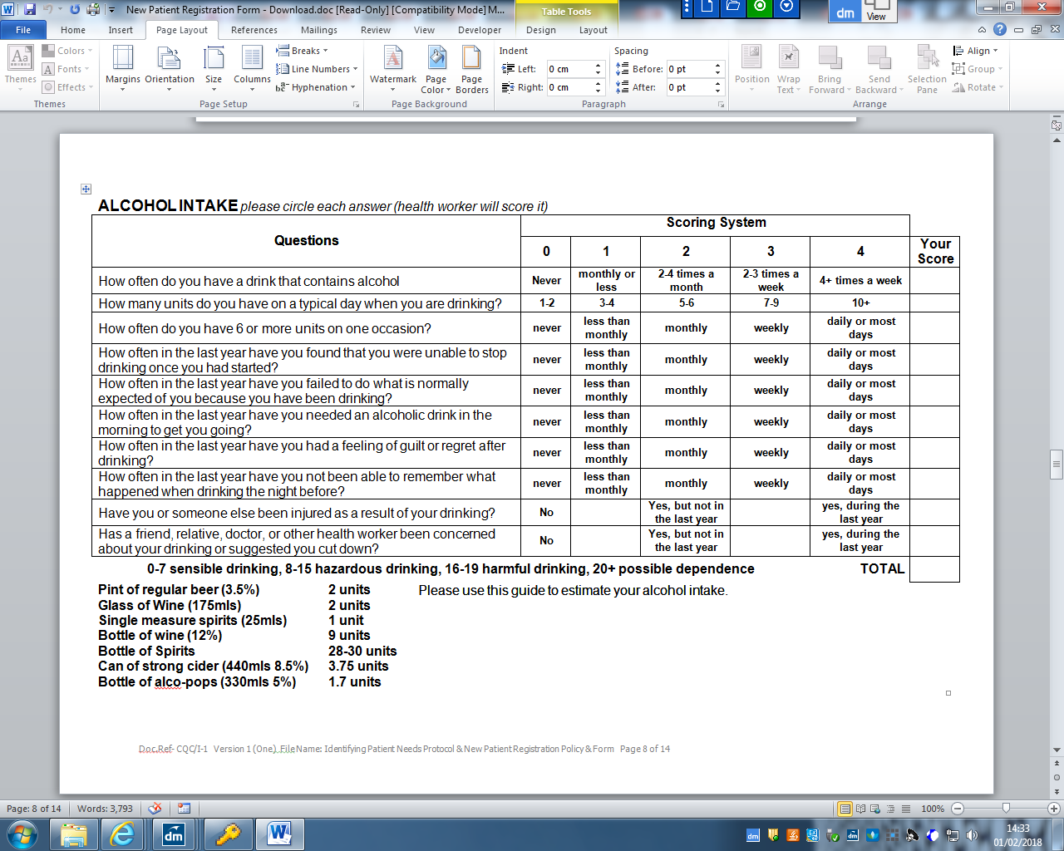



|  |  |
| --- | --- |
| **REGISTERING WITH CHILD HEALTH & HEALTH VISITING SERVICE**  **To be completed for all patients aged 0 – 19 years** | |
| Present GP: | Previous GP: |
| Mother’s Name: | |
| Present Address: | Previous Address: |
| Telephone: | Mobile: |
| Name: | DOB:  NHS Number: |
| Name: | DOB:  NHS number: |
| Name: | DOB:  NHS Number: |
| Name: | DOB:  NHS Number: |

**PLEASE EMAIL THIS FORM TO THE HEALTH VISITING SERVICE & CHILD HEALTH**

0 – 5 Years copy to Health Visitors 0 – 19 years copy to Child Health

**Health Visitors Staffordshire & Shropshire Health**

**Coral House Informatics Service**

**11 Longbow Court Mellor House**

**Harlescott Corporation Street**

**Shrewsbury Stafford**

**SY1 3GZ ST16 3SR**

Email: [**shrewburyhvteam@nhs.net**](mailto:shrewburyhvteam@nhs.net) and also a copy to **sshis.childhealth@nhs.net**

**Marden Medical Practice**

**Medical Records: Opt-Out Form**

If you would like more information about Summary Care Records and your choices, visit: https://digital.nhs.uk/services/summary-care-records-scr/summary-care-records-scr-information-for-patients

Please tick one or both options below:

|  |
| --- |
|  |

I do **NOT** want my Medical records to be uploaded to the National Spine (Summary Care Record). (9Ndo)

|  |
| --- |
|  |

I do **NOT** want personal confidential information held by my GP practice, shared beyond the needs of my individual care (9Nu0).

Section A: it is important that you complete this section accurately and please use BLOCK CAPITALS

|  |  |
| --- | --- |
| Title & Surname |  |
| Forename(S) |  |
| Address |  |
| Phone Number |  |
| Date of Birth |  |
| NHS Number (if known) |  |
| Patient Signature |  |
| Date |  |

If you are filling out this form on behalf of another person or child, their GP practice will check that you have the authority to do so. Please ensure you fill out their details in section A and your details in section B.

Section B:

|  |  |
| --- | --- |
| Your Name |  |
| Relationship to Patient |  |
| Your Signature |  |
| Date |  |

**\*\*\*Please return completed forms to Marden Medical Practice\*\*\***

For office use only

|  |  |
| --- | --- |
| 9Ndo added & Sharing Consent completed Y/N |  |
| 9NuO added Y/N |  |
| Initials |  |
| Date |  |



**For practice use:** To update the patient’s consent status to ‘Express consent for medication, allergies, adverse reactions and Additional Information’ use the SCR consent preference dialogue box or add Read code **9Ndn** (or CTV3 code **XaXbZ** for SystmOne practices).

NHS Summary Care Record with additional information

If you are registered with a GP practice in England you will have a Summary Care Record (SCR), unless you have previously chosen not to have one. It includes important information about your health:

* • Medicines you are taking
* • Allergies you suffer from
* • Any bad reactions to medicines

You may need to be treated by health and care professionals that do not know your medical history. Essential details about your healthcare can be difficult to remember, particularly when you are unwell or have complex care needs. Having an SCR means that when you need healthcare you can be helped to recall vital information.

SCRs can help the staff involved in your care make better and safer decisions about how best to treat you.

**You can choose** to have additional information included in your SCR, which can enhance the care you receive. This information includes:

* • Your illnesses and health problems
* • Operations and vaccinations you have had in the past
* • How you would like to be treated - such as where you would prefer to receive care
* • What support you might need
* • Who should be contacted for more information about you

**What to do next**

If you would like this information adding to your SCR, then please complete this form, for return to the relevant GP surgery.

Name of Patient: ………………………………………………..….....................................

Date of Birth: ……………………………. Patient’s Postcode: ………………………….

Surgery Name: ………………………….. Surgery Location (Town): ……….................

NHS Number (if known): …………………………..………………....................................

Signature: …………………………………………….. Date: ……………………………….

If you are filling out this form on behalf of another person, please ensure that you fill out their details above; **you** sign the form above and provide your details below:

Name: …………..............................................................................................................

Capacity: circle as appropriate Parent Legal Guardian Lasting Power of Attorney

If you require any more information, please visit **https://digital.nhs.uk** or phone NHS Digital on **0300 303 5678** or speak to your GP Practice

**Here at Marden Medical Practice we take your privacy seriously and will only use your personal information to administer your account and to provide the products and services you have requested from us such as appointment text message reminders.**

**However, from time to time we would like to contact you with details of other services we provide (for example Flu clinics, Smoking Cessation advice, Health Checks). If you consent to us contacting you for this purpose please tick the box below:**

**I give consent for Marden Medical Practice to contact me as detailed above**

**PLEASE NOTE – Any of your Medical Information that we hold may be needed by other Health Care Providers (e.g. opticians, physiotherapists, for referrals to hospitals)**

**If you are happy for us to share this information please tick the box below.**

**I give consent for my Medical Information to be shared with other Health Care Providers**

**If you require further information please view our Privacy Notice on our website: https://mardenpractice.gpsurgery.net**

**Patient Signature:**

**Signature on behalf of Patient:**

***Your physical examination will include having your height, weight and blood pressure taken, and a specimen of urine for testing (it would be helpful if you would bring a specimen with you when coming to the Practice).***

***The Consultation will also establish relevant past medical and family history, including:***

* ***Medical factors - illnesses, immunisations, allergies, hereditary factors, screening tests, current health***
* ***Social factors - employment, housing, family circumstances***
* ***Lifestyle factors - diet and exercise, smoking, alcohol and drug abuse.***

**Thank you for completing this form**

***For more information about the services that we offer, please refer to your***

***Practice Profile  
 or see our website: www.mardenpractice.gpsurgery.net***

**Patient Participation Group**

The Practice is committed to improving the services we provide to our patients.

To do this, it is vital that we hear from people about their experiences, views and ideas for making services better.

By expressing your interest you will be helping us to plan ways of involving patients that suit you.

It will also mean we can keep you informed of opportunities to give your views and keep you up to date with developments within the Practice.

If you are interested in getting involved, please tick the box below and we will arrange for the Practice Patient Participation Group Application Form to be given to you at your initial consultation.

Yes I am interested in becoming involved in the Patient Participation Group**:**

**EMIS ACCESS**

**For anonymity purposes and to safeguard your personal information, we would advise you to use the new Patient Access System for ordering your medication and booking routine DOCTORS appointments. You may also cancel these appointments online.**

**As well as ordering prescriptions, the system allows you to change personal details and leave the Practice a message online.**

**You will need to be registered in order to use this service.**

**Please speak to a member of the Reception Team if you wish to register or complete the form enclosed.**

|  |
| --- |
| Marden Medical Practice |

**Patient Online: Records Access**

**Patient information leaflet ‘It’s your choice’**

|  |  |
| --- | --- |
| If you wish to, you can now use the internet to book appointments with a GP, request repeat prescriptions for any medications you take regularly and look at your medical record online. You can also still use the telephone or call in to the surgery for any of these services as well. It’s your choice.  Being able to see your record online might help you to manage your medical conditions. It also means that you can even access it from anywhere in the world should you require medical treatment on holiday. If you decide not to join or wish to withdraw, this is your choice and practice staff will continue to treat you in the same way as before. In general this decision will not affect the quality of your care.  You will be given login details, so you will need to think of a password which is unique to you. This will ensure that only you are able to access your record – unless you choose to share your details with a family member or carer.  You will be required to produce documentation to prove your identity, (See below for the list of acceptable documents).  **The practice has the right to remove online access to services for anyone that doesn’t use them responsibly.** | **Repeat prescriptions online**  **GP appointments** **online**  **View your GP records**  **It will be your responsibility to keep your login details and password safe and secure. If you know or suspect that your record has been accessed by someone that you have not agreed should see it, then you should change your password immediately.**  **If you can’t do this for some reason, we recommend that you contact the practice so that they can remove online access until you are able to reset your password.**  **If you print out any information from your record, it is also your responsibility to keep this secure. If you are at all worried about keeping printed copies safe, we recommend that you do not make copies at all.** |

|  |
| --- |
| **Before you apply for online access to your record, there are some other things to consider.**  Although the chances of any of these things happening are very small, you will be asked that you have read and understood the following before you are given login details. |

|  |  |
| --- | --- |
| **Things to consider** | |
|  | **Forgotten history**  There may be something you have forgotten about in your record that you might find upsetting. |
| **Abnormal results or bad news**  If your GP has given you access to test results or letters, you may see something that you find upsetting to you. This may occur before you have spoken to your doctor or while the surgery is closed and you cannot contact them. |
| **Choosing to share your information with someone**  It’s up to you whether or not you share your information with others – perhaps family members or carers. It’s your choice, but also your responsibility to keep the information safe and secure. |
| **Coercion**  If you think you may be pressured into revealing details from your patient record to someone else against your will, it is best that you do not register for access at this time. |
| **Misunderstood information**  Your medical record is designed to be used by clinical professionals to ensure that you receive the best possible care. Some of the information within your medical record may be highly technical, written by specialists and not easily understood. If you require further clarification, please contact the surgery for a clearer explanation. |
| **Information about someone else**  If you spot something in the record that is not about you or notice any other errors, please log out of the system immediately and contact the practice as soon as possible. |

**ID Documents Required**

**Any two of the following three documents are acceptable: passport, driving licence, bank statement**.

**More information**

For more information about keeping your healthcare records safe and secure, you will find a helpful leaflet produced by the NHS in conjunction with the British Computer Society:

Keeping your online health and social care records safe and secure <http://www.nhs.uk/NHSEngland/thenhs/records/healthrecords/Documents/PatientGuidanceBooklet.pdf>

|  |
| --- |
| Marden Medical Practice |

**Patient Access to GP Online Services**

|  |  |  |  |
| --- | --- | --- | --- |
| Surname |  | | |
| First name |  | | |
| Date of birth |  | | |
| Address |  | | |
| Postcode |  | | |
| Email address |  | | |
| Telephone number |  | Mobile number |  |

I wish to have access to the following online services (tick all that apply):

|  |  |
| --- | --- |
| Booking appointments | 🞏 |
| Requesting repeat prescriptions | 🞏 |
| Accessing my medical record | 🞏 |

**Application for online access to my medical record**

I wish to access my medical record online and understand and agree with each statement (please tick)

|  |  |
| --- | --- |
| I have read and understood the information leaflet provided by the practice | 🞏 |
| I will be responsible for the security of the information that I see or download | 🞏 |
| If I choose to share my information with anyone else, this is at my own risk | 🞏 |
| I will contact the practice as soon as possible if I suspect that my account has been accessed by someone without my agreement | 🞏 |
| If I see information in my record that it not about me, or is inaccurate I will contact the practice as soon as possible | 🞏 |

|  |  |  |  |
| --- | --- | --- | --- |
| Signature |  | Date |  |

**For practice use only**

|  |  |  |  |  |  |
| --- | --- | --- | --- | --- | --- |
| Identity verified through  (tick all that apply) | Vouching 🞏  Vouching with information in record 🞏  Photo ID 🞏  Proof of residence 🞏 | | Name of verifier | | Date |
| Name of person who authorised (if applicable) |  | | Date | | |
| NHS number |  | Practice computer ID number | |  | |
| Date account created |  | | | | |
| Date passphrase sent |  | | | | |
| Level of record access enabled | Prospective 🞏  Retrospective 🞏  All 🞏  Limited parts 🞏  Contractual minimum 🞏 | | | | |

**Privacy Information**

# What is a privacy notice?

A privacy notice is a statement that discloses some or all of the ways in which the practice gathers, uses, discloses and manages a patient’s data. It fulfils a legal requirement to protect a patient’s privacy.

# Why do we need one?

To ensure compliance with the General Data Protection Regulation (GDPR), Marden Medical Practice must ensure that information is provided to patients about how their personal data is processed in a manner which is:

* Concise, transparent, intelligible and easily accessible;
* Written in clear and plain language, particularly if addressed to a child; and
* Free of charge

# What is the GDPR?

The GDPR replaces the Data Protection Directive 95/46/EC and is designed to harmonise data privacy laws across Europe, to protect and empower all EU citizens’ data privacy and to reshape the way in which organisations across the region approach data privacy. The GPDR comes into effect on **25 May 2018**.

# How do we communicate our privacy notice?

At Marden Medical Practice the practice privacy notice is displayed on our website, through signage in the waiting room, and in writing during patient registration (by means of this leaflet). We will:

* Inform patients how their data will be used and for what purpose
* Allow patients to opt out of sharing their data, should they so wish

# What information do we collect about you?

We will collect information such as personal details, including name, address, next of kin, records of appointments, visits, telephone calls, your health records, treatment and medications, test results, X-rays, etc. and any other relevant information to enable us to deliver effective medical care.

# How do we use your information?

Your data is collected for the purpose of providing direct patient care; however, we can disclose this information if it is required by law, if you give consent or if it is justified in the public interest. The practice may be requested to support research; however, we will always gain your consent before sharing your information with medical research databases such as the Clinical Practice Research Datalink and QResearch or others when the law allows.

# Maintaining confidentiality

We are committed to maintaining confidentiality and protecting the information we hold about you. We adhere to the General Data Protection Regulation (GDPR), the NHS Codes of Confidentiality and Security, as well as guidance issued by the Information Commissioner’s Office (ICO).

# Risk stratification

Risk stratification is a mechanism used to identify and subsequently manage those patients deemed as being at high risk of requiring urgent or emergency care. Usually this includes patients with long-term conditions, e.g. cancer. Your information is collected by a number of sources, including Marden Medical Practice; this information is processed electronically and given a risk score which is relayed to your GP who can then decide on any necessary actions to ensure that you receive the most appropriate care.

# Invoice validation

Your information may be shared if you have received treatment, to determine which Clinical Commissioning Group (CCG) is responsible for paying for your treatment. This information may include your name, address and treatment date. All of this information is held securely and confidentially; it will not be used for any other purpose or shared with any third parties.

# Opt-outs

You have a right to object to your information being shared. Should you wish to opt out of data collection, please contact a member of staff who will be able to explain how you can opt out and prevent the sharing of your information; this is done by registering a Type 1 opt-out, preventing your information from being shared outside this practice.

# Accessing your records

You have a right to access the information we hold about you, and if you would like to access this information, you will need to complete a Subject Access Request (SAR). Please ask at reception for a SAR form and you will be given further information. Furthermore, should you identify any inaccuracies; you have a right to have the inaccurate data corrected.

# What to do if you have any questions

Should you have any questions about our privacy policy or the information we hold about you, you can:

1. Contact the practice’s data controller via email at marden.marden@nhs.net. GP practices are data controllers for the data they hold about their patients[1]
2. Write to the data controller at Marden Medical Practice, 25 Sutton Road, Shrewsbury, SY2 6DL.
3. Ask to speak to the practice manager Mrs Zoe George, or their deputy Ms Debbie Turner.

# Complaints

In the unlikely event that you are unhappy with any element of our data-processing methods, you have the right to lodge a complaint with the ICO. For further details, visit ico.org.uk and select ‘Raising a concern’.

We regularly review our privacy policy and any updates will be published on our website, in our newsletter and on posters to reflect the changes. This policy is to be reviewed on 21st May 2019.

1.